Name: **FindSquareRootGUI**

Description: **Chapter 11 – Programming Exercise 3**

**Find the square root of a number**

Write a C# GUI application that finds the square root of an integer value entered by the user. The Math class contains a static method named Sqrt() that accepts a parameter and returns the parameter’s square root. If the user’s input value cannot be parsed to int, display the message shown. If the user’s input value is a negative value, throw a new ApplicationException to which you pass the message shown. If the user’s input value is a positive integer, pass it to the Math.Sqrt() method and display the returned value to four decimal places. The findButton is to be designated as the Accept button. The exitButton is to be designated as the Cancel button. Access Keys are to be assigned to all buttons on the GUI. Set the Tab index to a logical order. Design your GUI as shown.

Create a Click event method for the findButton. Within the method, create the necessary variables. Create the try block that contains an if-else statement to determine if the user’s input value can successfully parsed to int. If parsed successfully, calculate and display the square root using the square root method shown above. Otherwise, display the entire “not an int number” message. Also, within the Try block, create an if statement that determines if the user entered a negative integer number. If a negative integer number was entered, throw a new ApplicationException and pass it the entire “can’t be negative” message. Create a catch block to handle the ApplicationException by displaying the *thrown* message text. Items in the display label are to appear as shown.

Create a Click event method for the exitButton that terminates the application.

Complete the Pseudocode Template document for this programming request. A printed version is due upon arrival to class on lab day.

Use your completed Pseudocode document to create the C# application. Create and save the application to your classroom USB flash drive.

GUI When Started Sample Program Output (1) – 81 entered

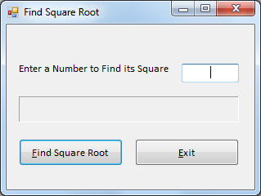 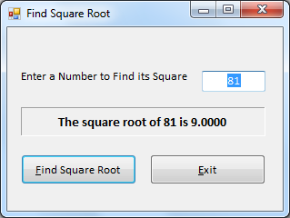

Sample Program Output (2) – 112 entered Sample Program Output (3) – 9 entered

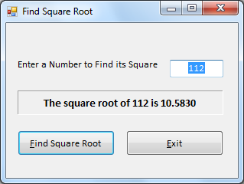 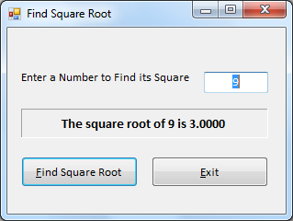

Sample Program Output (4) – 100.5 entered Sample Program Output (5) – 99 entered

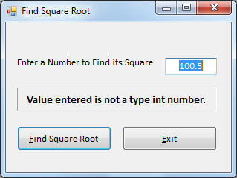 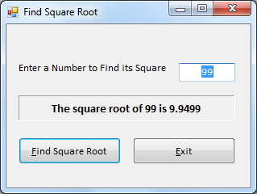

Sample Program Output (6) – -9 entered

